Topic Me and my home
Level: Entry 3
Time: 90 - 120 minutes. You may wish to split this lesson over two sessions.

Aims
- To familiarise learners with ESOL Skills for Life E3 exam.
- To develop learners’ vocabulary of homes and related language.
- To further practise speaking and listening skills.

Objectives
Learners will have begun to:
- Speak and listen using the exam format.
- Understand exam conditions and some exam instructions
- Complete typical reading and writing exam tasks
- Developed language related to the topic of ‘homes’.

Introduction
This lesson is about houses and running a home. It provides some language required to understand exam instructions and for the subject of ‘homes’ in all modes.
.
It is likely that some of the learners will be familiar with the format of the exam so the emphasis is on providing opportunities practise their skills ahead of the exams, with a focus on speaking and listening.

Should you wish to use the lesson plan for another topic in the exam range, it is possible to substitute the content with the required topic and source relevant materials in a variety of genres.

Tip! Collate as many different genre materials on the given topic as possible: e.g. instructions, leaflets, email, blog etc.
See the ESOL Core Curriculum notes, as provided by notes from the awarding body for a full range of genres.

Preparation

You will need:

- Resource 1: images of different types of housing and rooms, to display and cut up sets to share between 3 or 4 learners.
- Resource 2: reading text, one per learner
- Resource 3:comprehension questions, one per learner
- Resource 4: form, one or two copies per learner.
- Realia: relating to housing:, estate agent magazines, newspaper homes for sale/rent sections, forms related to housing or general, leaflets, recipes and other text types.
- Exam board handbook and assessment guidelines
- Past or sample papers.

Procedure

Warmer (5-10 minutes)
- Give each group of 3 or 4 a set of pictures of different types of housing: flat, bungalow, detached, semi-detached, terraced etc.
- Ask learners to choose one each, name it and think of two sentences to define their chosen dwelling and describe how it is different from the others.
- Project or display each dwelling in turn and invite the learner/s who chose it to name and describe it.
- Either ask a learner to write the name on the board and one to three key words from their definition, or ask them to spell the words as you write.
Tip! You could source more images of housing from a newspaper ‘for sale’ section, estate agent promotional papers or course / library books.

Activity 1 – speaking and listening: furniture and DIY (20 minutes)
- Draw a four square grid on the board with one word in each box: lounge, kitchen, bathroom, bedroom. Display the images of rooms from resource 1.
- Elicit the furnishings vocabulary to go in each room and board in the correct room square.
- Write the acronym DIY on the board, next to the grid, and ask learners what this means: Do It Yourself.
- Ask learners if any of them has done any DIY. Invite one to tell you about their experience. You could focus on furniture e.g.
‘Did you make piece of furniture? put together flat pack furniture? Fix something?’ or decorate / fix something in a room.
- Ask learners open questions about their story e.g. ask ‘What happened next? How did you feel? How does the story end?’
- Board all the vocabulary relating to DIY: painting, plumbing, build, decorate, refit, design etc.
- Group learners to work in groups of 2-3 at the same level to take it in turns to tell their stories and ask/answer questions.
- If only a few of them have done any DIY make sure at least one is in each group – they can be the story teller and the others just ask the questions.
- Ask learners to report back to the whole class on the questions they were asked. Which questions showed the others were listening? Which ones helped them to think of more things to say.
- Explain that they will have to ask their examiner questions. Ask them to make a note of the questions.

Activity 2 – reading and grammar: running a home (25-30 minutes)
- Ask learners what is required to run a home: electricity, gas, insurance, mortgage/rent, council tax.
- Lead the discussion into the importance of ‘budgeting’ and ‘saving money’ and ‘energy’ and different types of energy: solar, wind, hydro etc.
- Explain that you are going to take them through some typical exam style questions relating to the reading exam.
- Hand out resource 2 and read as a group by turn taking in the group.
- Ask some simple questions about the layout, headers, and pictures in order to get them used to questioning a text. E.g. do you like the layout? Where would you see something like this? In a newspaper? As an advert? How do the pictures help understand the information?
- Point to the different features and ask learners to name them (title, heading, bullet points, table) and say what their purpose is.
- Add some questions of your own that you think will be useful to your group.
- Hand out resource 3 and elicit or explain the purpose of each question:

  - Question 1: to relate image to text. Explain that pictures are important in helping us to understand what the text is about.
  - Questions 2&3: knowing the alphabet and using a dictionary. Bi or monolingual dictionaries are now allowed. Alphabetic ordering and use of a dictionary should practised often to help learners with this part of the exam.
  - Question 4 & 5: each of these questions can be incorporated into daily lessons. When looking at texts in class, ask questions about the layout; and the word classes ‘find a noun/adjective/comparative etc. in the text, in order that this becomes a familiar exercise.
  - Question 6: can be practised by writing short sentences on the board with spelling/grammar/punctuation mistakes, and when they make mistakes in their own work tell them there is a mistake and leave them to find it in the: line, sentence or paragraph.
  - Questions 7 – 10: these are detail questions and can be practised whenever reading a text in class to build familiarity.
- Upon completion, answer the questions to the whole group and discuss, ensuring all learners understand fully, as each question relates to a part of the exam.

Tip – try not to be drawn into answering questions about resource 2ahead of students completing resource 3, as many of the questions they may ask are on worksheet 2. Encourage them to try themselves first.

Activity 3 – form filling and speaking practice (15-20 minutes)
- Discuss what is typically asked for on a form e.g. name, address, postcode, phone number.
- With learners in groups of 2-3, ask them to tell each other their name, address and phone number and spell their full name. Suggest that they use their own names with made up addresses and phone numbers.
- This forms part of the speaking and listening exam and will help learners form the question ‘what is your name, address and telephone number. Spell your name.’ And to answer appropriately.
- Hand out resource 4 and elicit the different parts of the form:
  - Names can be asked for in a variety of ways: delete as appropriate for titles, first name/forename, surname/family name/last name. Demonstrate on the board and regularly in lessons.
  - Phone numbers have 11 digits beginning with ‘0’.
  - Pre teach an email address in case they are not familiar with these.
  - Explain ‘optional’ by integrating into daily lessons as ‘answer all the questions, question 9 is optional’ and check for understanding.
  - Multiple choice questions can be practised in lessons.
  - Contact details can be practised regularly in class as a general question: how can we contact people today: email, phone, IM, Facebook, text, Skype and demonstrate what they look like. Put one of each on the board and ask them to say what they are.
  - It is a good idea to bring in a range of real forms related to the chosen topic for them to practise.
- Ask learners to work in pairs to practise filling in forms with one person asking for the information and writing it in the correct place. They can use resource 4 or a real form you have brought in.
- Give learners a clean copy of resource 4, or a real form, and ask them to complete filling it in independently under exam conditions, in order to prepare them for the day.
  - Silence, no looking around, no leaving the room, raise your hand if you have a question, stay in your seat.

Activity 4 – genres (10-15 minutes)
- Hand out pre-sourced materials to groups of three or four e.g. recipes – instructions, a sales advertisement– advert, a healthcare leaflet – advice etc.
- Ask learners to identify the purpose of each text: – persuade, selling something, advice, information.
- Ask them to sort them by type and then compare how another group has sorted theirs.
- Discuss any differences and help them to decide which one is right or if the text can fit into more than one group.
Tip – You could also use these texts for learners to identify key features of texts – headings, bullet points etc and word classes.

Activity 5 – writing (15-25 minutes)
- Elicit what a ‘paragraph’ is.
- To teach this you can:
  - Project a page of text on the topic, or one that is familiar to learners, with the paragraphing removed. Ask what they notice about this text, elicit that paragraphs are missing and that it makes it difficult to read. Work with them to decide where the paragraph breaks should be made, add headings if appropriate.
  - Provide a short text pre-cut into paragraphs for learners to re-order.
  - Remove the sub headings from paragraphs and provide separately for learners to match the subheadings to the text.
- Demonstrate a ‘mind-map’ on the board by asking a learner what they are going to write about and place this in the middle of the board:
  - Put the stages of the story as separate headings around the ‘title’.
  - Explain that each stage is a paragraph.
  - Invite the class to create their own ‘mind-map’.
- Invite learners to write 3 paragraphs about one or all of the following: homes in their country and here; a DIY story they are familiar with; likes and dislikes of different types of energy.
Differentiation/ extension
- The writing task can be completed as a homework activity if time is short.
- The writing task can be reduced to 50 words for E2.
Cooler Furnishing my house
- Ask learners to stand in a circle. Throw a soft ball or scrunched up paper at a learner and say a name of a room e.g. kitchen
- The learner has to say ‘In my kitchen I have a fridge’ . They then throw the ball to another learner while naming another room.
- Learners must not repeat an item that has been mentioned.
- Continue until all learners have had two or three turns.

Extension activities / Homework
- Learners can complete additional written tasks for homework as outlined in this lesson plan or on additional topics.
- Encourage learners to access the library and find out about alternative power: wind, solar, hydro etc.
- Present additional reading tasks through authentic sourced materials and asking comprehension questions similar to those in the exam, on a range of topics.
- For speaking and listening practice, learners could tell their stories and the class could ask questions, or as a mini discussion.
Tip – the more exposure the learners have to a variety of texts, the better prepared they will be, both for the exam and real life.

Resource 1
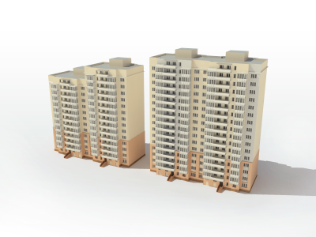

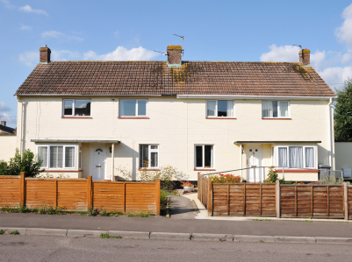

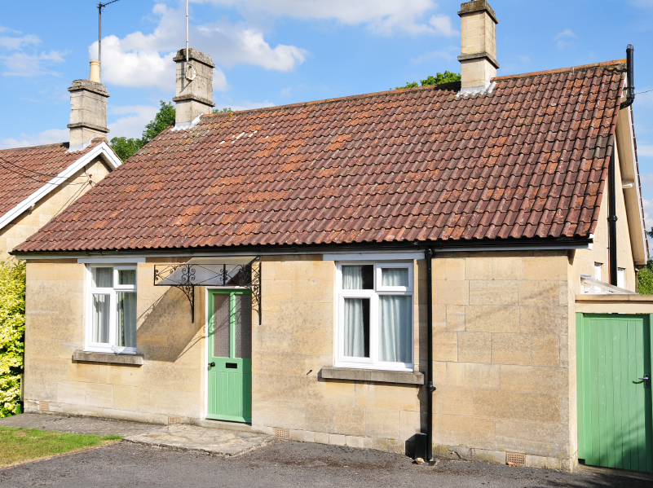

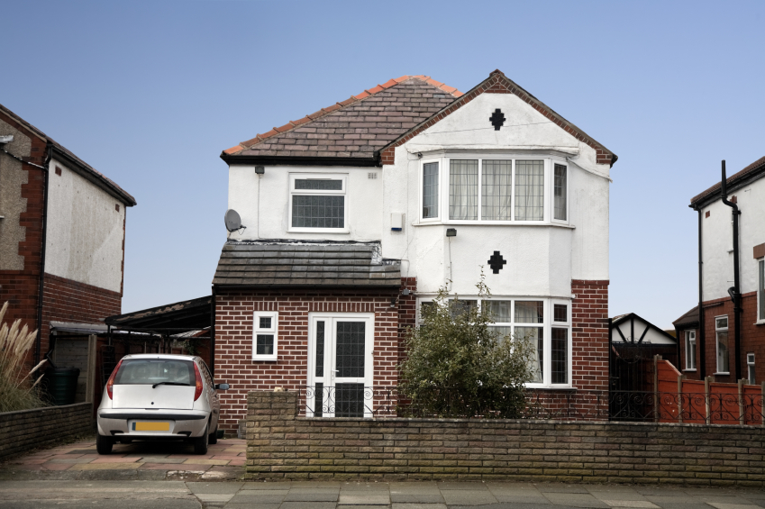

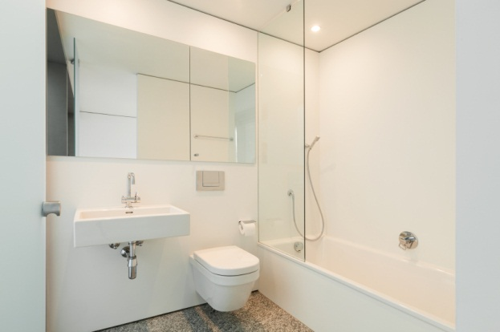

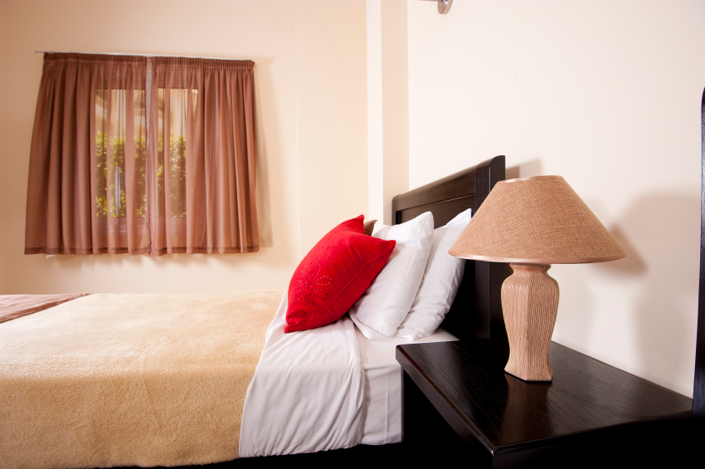

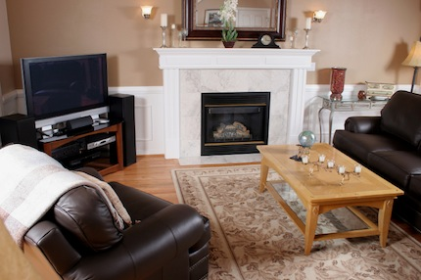

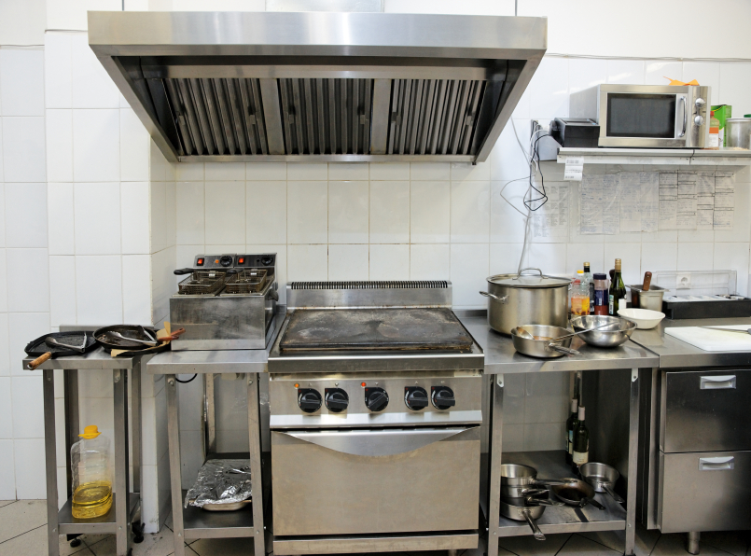

Resource 2
Running a Home

Running a home is something we all have to do at some time in our lives, yet we are not taught how to do this in school!
This leaflet has been prepared to help you decide which is the best housing for you, understand better the energy choices available, and some good tips on how to save money when running a home.

Types of housing
In the UK we have traditionally lived in houses: detached, semi-detached, or terraced. If there is a housing shortage then the governments have ordered flats to be built to meet the demand. Today there are many flats being built in the UK.
- Detached houses: stand alone. They have no other property attached to them and generally have gardens to the front and rear. They also tend to have 3+ bedrooms.
- Semi-detached: have a house attached on one side. These are often smaller than detached properties; though not always.
- Terraced: a row of houses all joined together. Traditionally ‘2 up 2 down’ design. Commonly used in big cities where housing is short and have a back yard, or small garden.
- Flat: small dwellings built in blocks over several floors. Generally no garden, or a shared garden.

Saving money
There are many ways of saving money in our homes. If you want to save money on fuel, choose your energy provider carefully as the rates vary a lot! It might be worth investing in solar panels if you are planning to stay in your home for a long time. This can reduce your bills tremendously. When planning home improvements, why not do a bit of DIY? Most people can do a bit of painting and decorating and save a fortune, and those with a bit more skill and confidence might want to refit a bathroom or kitchen! Ben said ‘I saved £200 by decorating my own living room’.
Energy sources

Solar  Energy captured by the sun. Very popular and encouraged by power providers. They can be fitted to the roof of your house to save money.  For more information: http://www.solartech.org.uk/ | Wind  Energy harnessed by the wind. Whilst these can be installed in your  home, they are commonly installed at sea and in fields to supplement the national grid. | Hydro  This is water energy. Commonly used in  water wheels but now the government is approving harnessing energy from the sea. There are concerns over the impact on nature.

Resource 3 Running a home – questions

- Write the correct word in the boxes below the pictures.
Detached semi-detached flat bungalow terraced
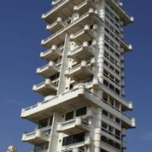 | 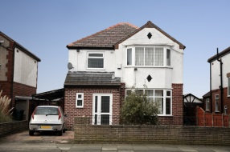 | 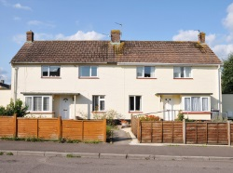 | 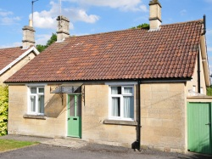 | 
 | Detached
- Put the words in the box in alphabetical order
DIY reduce home improvements
budget PROVIDER energy
fuel invest

- Look up ‘provider’ in your dictionary and write the meaning below.
________________________________________________________________
- Label examples of the following on resource 1. One of them can be found on this sheet.
Columns internet link italics bullet points
quote subheadings images
- a Find the superlative in the opening paragraph.
b What is the adjective and comparative form?
c Find 1 more example of a comparative form in the section ‘Types of housing’
- In the section ‘Types of housing’
a Find and correct the spelling mistake here ____________
b Write the conditional sentence here If___________________then_____________________________
- Why are there a lot of flats being built today?
__________________________________________________________
- What does ‘2 up 2 down’ mean?
- 2 people live upstairs and 2 downstairs. b) 2 rooms upstairs and 2 downstairs
- In the section ‘Saving money’, which word means ‘a lot’? ______________
- In the section ‘Energy sources’ which one can be installed in your home? _____________________

Resource 4 Form filling
ENERGY INFORMATION
Customer information

Property details

Interests

Enter our competition to win free solar panels
Tell us two reasons why Solar energy is a good thing.
_______________________________________________________
_______________________________________________________
How would you prefer to be contacted: phone, email or post? ________
For further information contact Bill Paterson 07877421566 email b.patterson@fuel.com

Title ___________ Forename _____________
Surname__________ D.O.B_____________
Address______________________________________________ Postcode_____________________________________________
Email ________________________________________________
Home telephone ______________ work (optional)___________
mobile_______________

Year built No. of beds

Flat
Mid terrace End terrace
Detached Semi Detached
Bungalow House

Would you be interested in the following:

Saving money on utility bills?
Solar technologies?
Energy rated replacement windows?
Central heating upgrades?
Top tips to saving money in your home?

- Which information can be left out?________________________

- Which two ways can you contact the company? _____________
______________________________________________________

Answers

Resource 2
- Flat, detached, semi-detached, bungalow, terraced.
- Budget, DIY, energy, fuel, home improvements invest, reduce.
5) a) best b) good, better c) smaller
6) a) traditionally
b) If there is a housing shortage then the governments have ordered flats to be built to meet the demand.
7) Housing shortage
8) b
9) tremendously
10) solar

Resource 3
- Work
- Phone, email

